Software Requirements Specification

for
MEAT BAZAR GROCERY MANAGEMENT SYSTEM
Requirement Engineering:
Zaheen Abrar | 22-48467-3
Mazumder Redwanul Haque | 22-48481-3
Fahmida Rahman | 22-48483-3
MD Tanjim Hossain | 23-51464-1

Table of Contents
Table of Contents ii
Revision History ii
1. Introduction 1
1.1 Purpose 1
1.2 Document Conventions 1
1.3 Intended Audience and Reading Suggestions 1
1.4 Project Scope 1
1.5 References 1
2. Overall Description 2
2.1 Product Perspective 2
2.2 Product Features 2
2.3 User Classes and Characteristics 2
2.4 Operating Environment 2
2.5 Design and Implementation Constraints 2
2.6 User Documentation 2
2.7 Assumptions and Dependencies 3
3. System Features 3
3.1 System Feature 1 3
3.2 System Feature 2 (and so on) 4
4. External Interface Requirements 4
4.1 User Interfaces 4
4.2 Hardware Interfaces 4
4.3 Software Interfaces 4
4.4 Communications Interfaces 4
5. Other Nonfunctional Requirements 5
5.1 Performance Requirements 5
5.2 Safety Requirements 5
5.3 Security Requirements 5
5.4 Software Quality Attributes 5
6. Other Requirements 5
Appendix A: Glossary 5
Appendix B: Analysis Models 6
Appendix C: Issues List 6

Revision History
Name | Date | Reason For Changes | Version
Meat Bazar | 26-01-21 | Initial Final SRS | 1.0

Introduction

Purpose
This Software Requirements Specification (SRS) document provides a complete and detailed description of the functional and non-functional requirements of the Meat Bazar system. The purpose of this document is to serve as a reference for developers, testers, project managers, and stakeholders during the design, development, testing, and maintenance phases of the project.

Document Conventions
• Shall indicates a mandatory requirement.
• Should indicates a recommended requirement.
• May indicates an optional requirement.
• Functional requirements are labeled for traceability.

Intended Audience and Reading Suggestions
This document is intended for:
- Software developers
- Software testers
- Project managers
- Business stakeholders

Project Scope
Meat Bazar is a digital marketplace accessible via web and mobile platforms, designed to facilitate connections among farmers, collectors, distributors, and customers in the meat industry. The marketplace aims to create a transparent pricing structure and improve logistics, while ensuring secure payment processes and dependable delivery of meat products. Its core mission is to eradicate exploitative intermediaries that can distort pricing, thereby fostering a fairer economic environment for both producers and consumers in the meat supply chain.

References
- IEEE 830 Software Requirements Specification Standard

- Agile Manifesto

- Bangladesh Digital Commerce Policy

Overall Description

Product Perspective
Meat Bazar is a comprehensive system that integrates e-commerce, inventory management, logistics coordination, and digital payment services, functioning independently while also interacting with external services like payment gateways and SMS providers.

Product Features
- User registration and authentication
- Role-based access control
- Online meat ordering
- Inventory management
- Order tracking and delivery management
- Digital payment processing
- Reporting and analytics

User Classes and Characteristics
User Class | Description
Admin | Manages system configuration, users, inventory, and reports
Collector | Supplies meat and manages stock levels
Distributor | Handles delivery and logistics
Customer | Browses products and places orders

Operating Environment
- Web browsers (Chrome, Firefox, Edge)

- Android and iOS platforms

- Cloud-based server infrastructure

- MySQL/Firebase database

Design and Implementation Constraints
• Integration with Bangladeshi payment gateways such as bKash and Nagad.
• Compliance with local trade and food safety regulations.
• Support for English and Bengali languages.

User Documentation
• User manuals
• Online help system
• Admin documentation

Assumptions and Dependencies
• Users have access to stable internet connections.
• Payment gateways remain operational.
• Government regulations remain consistent.

System Features

User Registration and Authentication
Priority: High

Description: The system allows users to register, log in, and access role-based dashboards securely.

Stimulus/Response Sequences
• User selects Sign Up and submits details
• System verifies user via OTP
• Account is created and dashboard is displayed

Functional Requirements
• REQ-01: The system shall allow users to register using phone number or email.
• REQ-02: The system shall verify users using OTP.
• REQ-03: The system shall allow users to reset forgotten passwords.
• REQ-04: The system shall provide role-based dashboards.

Order Management
Priority: High

Description: Customers can place orders, and distributors manage order fulfillment.

Stimulus/Response Sequence:
- Customer adds items to cart and places order
- System confirms order
- Distributor processes and updates order status

Functional Requirements:
- REQ-05: Customers shall be able to place meat orders.
- REQ-06: The system shall display real-time order status.
- REQ-07: Users shall be able to cancel orders within a defined time window.

Inventory Management
Priority: High
Description: Collectors and admins manage meat stock levels.

Functional Requirements:
- REQ-08: Admin shall manage meat categories.
- REQ-09: Collectors shall update stock quantities.
- REQ-10: The system shall generate low-stock alerts.

Payment Processing
Priority: High
Description: The system processes secure digital payments.

Functional Requirements:
- REQ-11: The system shall support bKash, Nagad, and card payments.
- REQ-12: The system shall generate digital payment receipts.
- REQ-13: The system shall maintain transaction history.

Reporting and Analytics
Priority: Medium
Description: System generates analytical reports for different roles.

Functional Requirements:
- REQ-14: Admin shall view overall sales reports.
- REQ-15: Distributors shall view delivery performance reports.
- REQ-16: Collectors shall view income summaries.

External Interface Requirements

User Interfaces
• Responsive UI design
• Dashboard-based navigation
• Multilingual interface

Hardware Interfaces
• Smartphones
• Desktop and laptop computers

Software Interfaces
• Payment gateway APIs
• SMS and email notification APIs

Communications Interfaces
- HTTPS protocol
- Restful APIs

Other Nonfunctional Requirements

Performance Requirements
• System response time shall be less than 3 seconds.
• System shall support at least 5,000 concurrent users.

Safety Requirements
• Role-based access control
• Encrypted passwords
• Two-factor authentication

Security Requirements
• System uptime shall be at least 99%.
• Daily automated data backups shall be maintained.

Software Quality Attributes
• System shall be easy to learn for new users.
• Clear error messages shall be displayed.

Other Requirements
• Compliance with Bangladeshi e-commerce laws
• Support for local currency (BDT)

Appendix A: Glossary
- OTP: One-Time Password
- UI: User Interface

Appendix B: Analysis Models
- Use Case Diagram
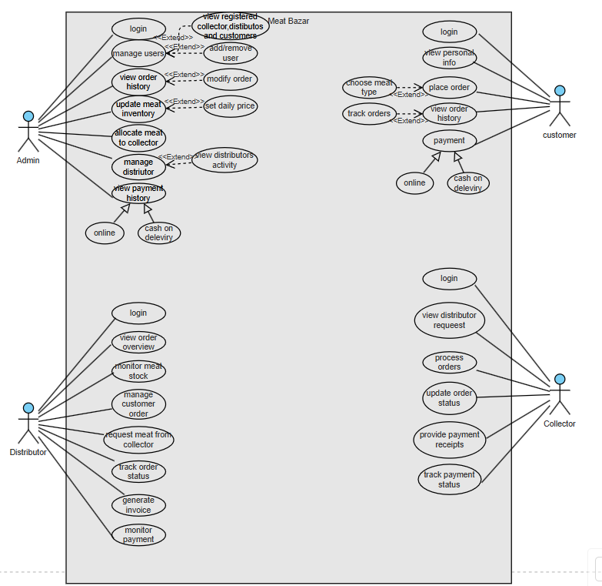

- Class Diagram
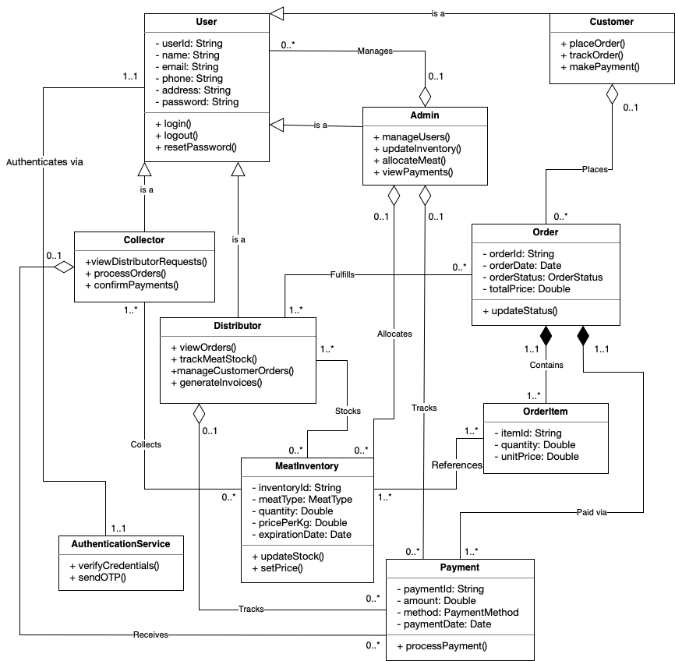

- Sequence Diagram:
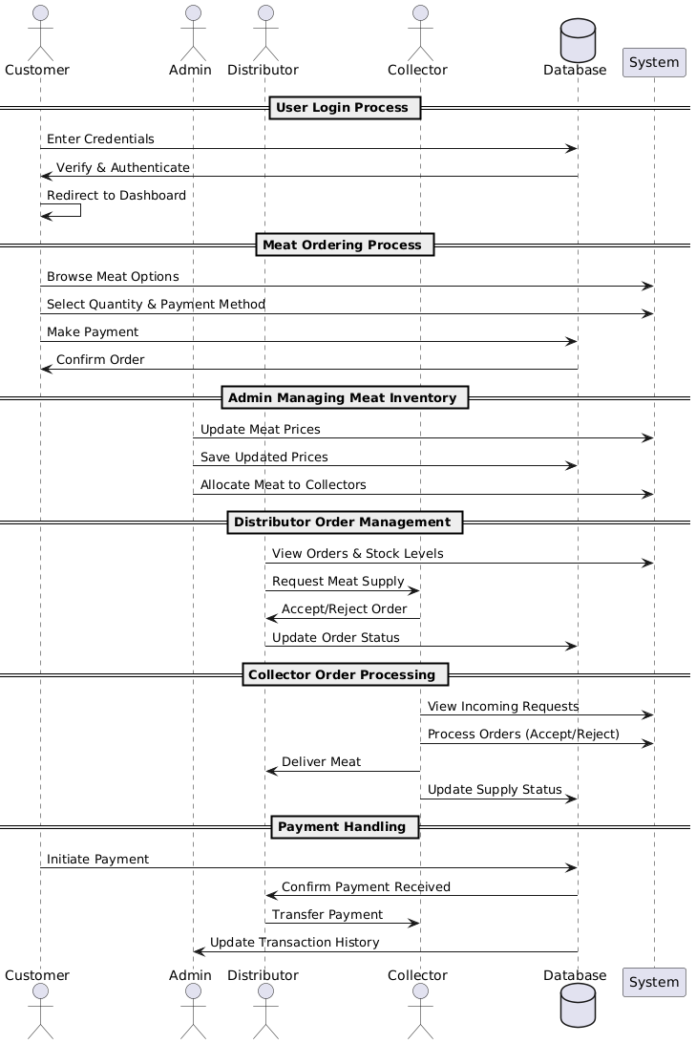

- Activity Diagram:
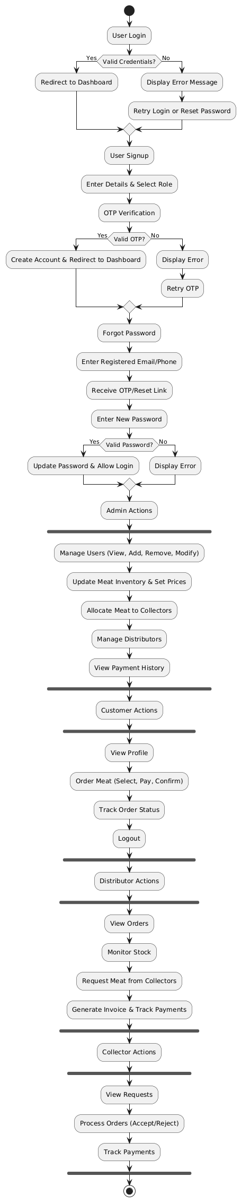

- State Diagram:
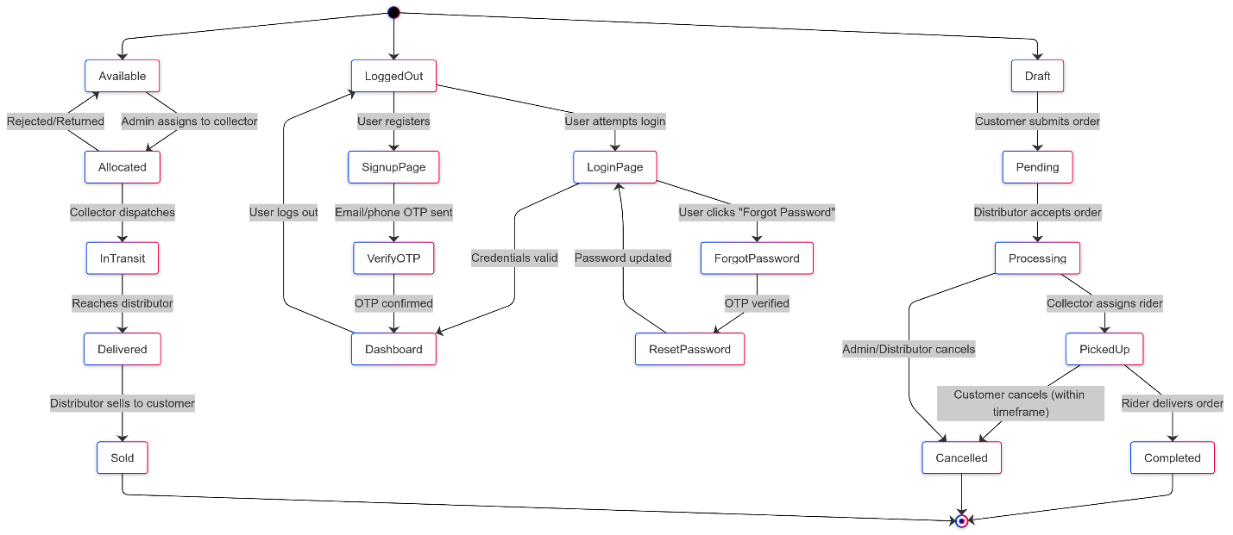
Appendix C: Issues List
- Pricing algorithm finalization
- Government system integration pending

